Dipole on TMD to confine excitons

Very recently, there has been much progress in using high inhomogeneous electric fields to confine excitons, producing single quantum emitters (quantum dots). Such quantum dots are interesting as sources of individual photons and for quantum simulations. The idea is to use two electrodes separated from the TMD by a thin hBN to generate the strong in-plane field; such a field leads to potential localizing TMD excitons. When the field is large and localized enough, excitons are confined within “a quantum dot”.
To give typical parameters: using electrodes placed 50nm away, fields in the range of 40V/um (0.04V/nm) are generated, resulting in confinement potential with the depth of few meV and special extent a few tens of nm (Nature 606, 298 ‘2022):

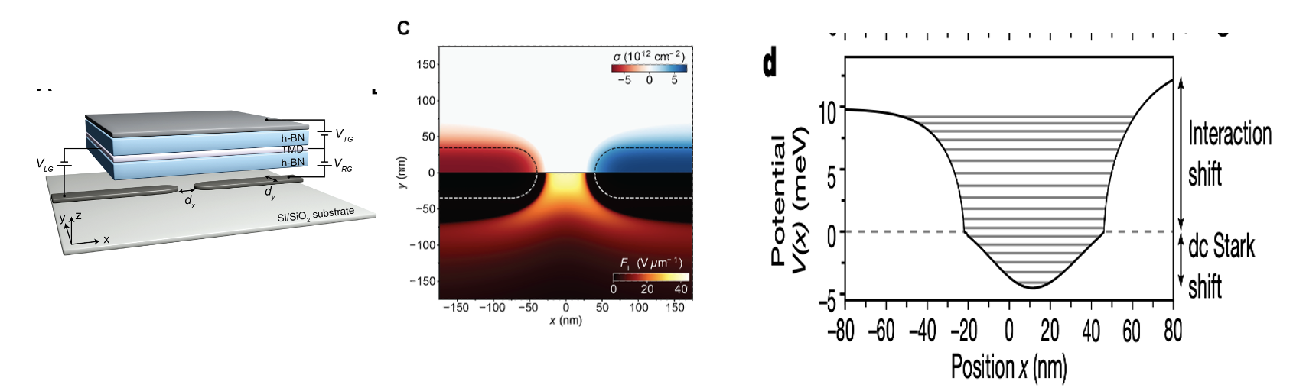

Our idea is to use a molecule with a large dipole moment instead of gates to generate the field producing confinement. Here is the geometry we want to use:
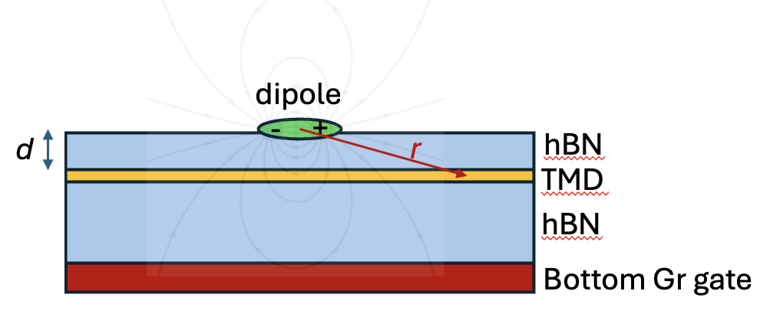

The key parameters here are the dipole moment of the molecule p and the thickness of the top hBN d (separation between the molecule and TMD). For molecules, we model molecules from the Eigler group with the dipole moment of 40 Debye (0.8e*nm). We estimate the field inside TMD using a simple dipole potential (this assumes that TMD is charge neutral and neglects hBN):

$$\vec{F}=\frac{1}{4πϵ_{0}} \frac{3\left(\vec{p} \vec{n}\right\}\vec{n}- \vec{p}}{r^{3}}$$

Here r is the vector between the center of the dipole and the observation point inside TMD and $\vec{n}$ is the unit vector in its direction. We get the following field for different dipole/TMD separations:
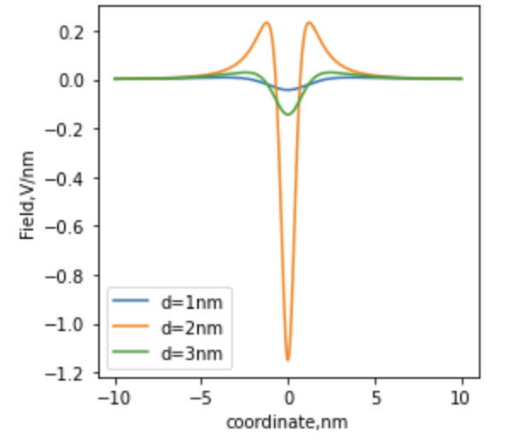
Note that the field is bigger than what you get with electrostatic gates even for 3nm hBN thickness. Now let us calculate the potential for excitons this field produces using only the contribution of the linear Stark effect, $V\left(x\right)=-αF{\left(x\right)}^{2}/2$ , where $α=6.5$ eV nm²/V² (Nature 606, 298 ‘2022):
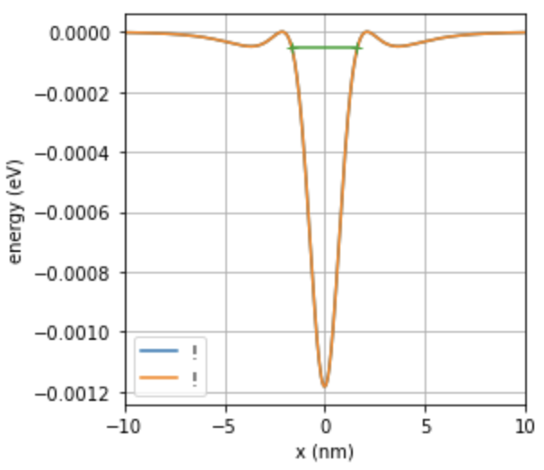
We get a >1 meV deep potential, close to what is shown in the paper. Does it confine excitons? We can answer this question by using quasiclassical (WKB)conditions for confinement:
$$\frac{1}{ℏ}\int_{b}^{a}{pdx}=π\left(n+\frac{1}{2}\right)$$

In this equation $p=\sqrt{2m\left(E-V\left(x\right)\right)}$ is the momentum of a particle with energy E in potential V(x), m is the excitonic mass assumed to be 0.27m_{e} (Commun Phys 3, 194 (2020)), a and b are classical turning points (p=0), and n is the integer number labeling the state.

For the potential above, we calculated the turning points for the highest energy in that potential (the green line shows the turning points). Unfortunately, this integral has the value 0.18< $π/2$ . This means that there are no confined states in it So for 3nm separation, we do not get excitonic confinement.

We now decrease the parameter d – that increases potential depth -- and see when the confined states first appear. This first happens when d=0.9nm (trilayer hBN):
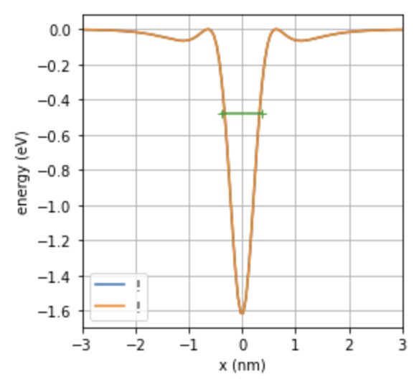
You can see that the potential is deep and narrow. The integral calculated between the turning points labelled green on the picture is about $π/2$ which means there is a confined state about 0.5eV below 0 in this potential! (Note, only one confined state!) This may be observable. In PL, a very narrow single quantum emitter state will appear at about 1.2 or so eV and will disappear when the sample electron or hole doped.

To make these estimates better, we may:
- Include more precise field calculation accounting for top hBN (now it is counted as vacuum)
- Add additional field component to the dipole potential coming from interaction with charges
- Maybe go beyond quasiclassical energy estimates by explicitly solving the Schrodinger equation.

